**Literature Review Report**

**Executive Summary**

**Introduction**

The diseases are not considered skin diseases, and skin tone is majorly suffered from the ultraviolet rays from the sun. However, dermatologists perform the majority of noninvasive screening testssimply with the naked eye, even though skin illness is a frequent disease for which early detection and classification are essential for patient success and recovery. Due to the ease with which the condition might be missed, this may result in unnecessary diagnostic errors caused by human error. Furthermore, because the symptoms of many common skin diseases share a great deal of similarity, disease classification is challenging The classification of skin diseases using machine learning was the subject of a large number of earlier studies that were compiled in this publication. Skin disease classification has been accomplished by several methods, with varying degrees of diagnostic precision. Numerous systems have relied on image processing and feature extraction techniques to identify and forecast the type of disease . There are additional techniques created to recognize particular types of skin diseases using clinical characteristics and characteristics discovered by tissue analyses following a skin biopsy of the affected area. In commonly skin diseases are considered conditions and it is affected by our skin the main concepts of skin diseases may be considered as rashes, inflammation, and itchiness or the skin suffering.

**Outline of Methodological Approach**

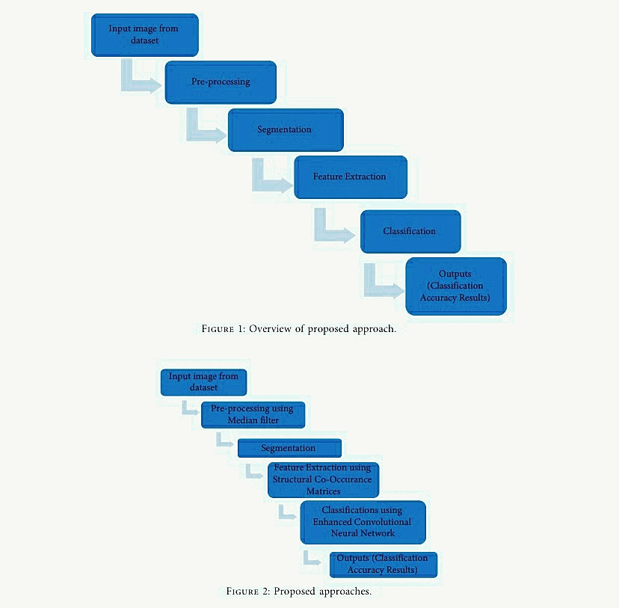

**Identification, Selection and Analysis of the Literature**

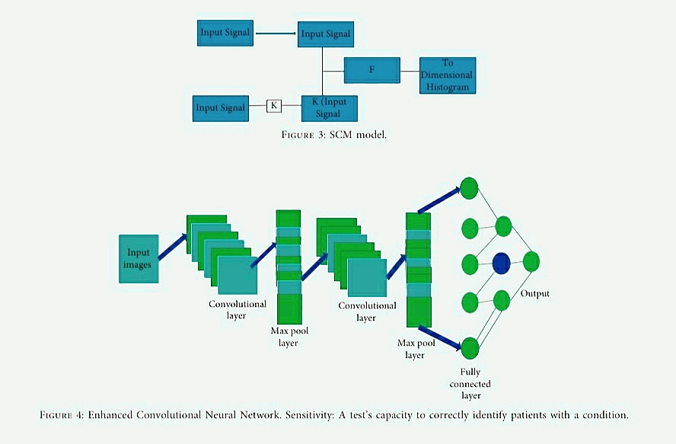

**Findings**

The result of this analysis gives that the enhanced results when compared to the existing technique. Verma et al. presented the Digital Diagnosis of Hand Foot and mouth disease using hybrid Deep Neural Network.diagnosis and the datasets are classified by using the MobileNet. Rebouças Filho et al. implemented the Automatic histologically–closer classification of skin lesions.Finally it explains the accuracy classifications of the images. Alsaade et al. implemented the Developing a recognition system for diagnosing melanoma skin lesions using artificial intelligence.Deepa and Devi implemented the survey on artificial intelligence for medical image classification.Hameed et al. implemented an intelligent computer-aided scheme for classifying Multiple skin lesions, the skin diseases are classified by using the Computer-aided Diagnosis System (CAD). Hemanth et al. implemented the enhanced diabetic retinopathy detection and classification approach using a deep convolutional neural network.Chieregatoet et al. implemented the hybrid Machine learning/deep learning COVID-19 severity predictive model from CT images and clinical data this paper proposed the accuracy of the classifications.e 3100 Dermoscopy images collected from the PH2 and the ISIC datasets; except for the PH2 datasets, all the datasets are the resizing images, and it has different types of images, and the final results are based on the accuracy results in the form of the melanoma and the nonmelanoma skin diseases classifications.

**Conclusion and Future Work**

This paper implements that the Structural Co-Occurrence matrices for feature extraction in the skin diseases classification and the preprocessing techniques are handled by using the Median filter, this filter helps to remove the salt and pepper noise in the image processing; thus, it enhances the quality of the images, and normally, the skin diseases are considered as the risk factor in all over the world.

Our proposed approach provides 97% of the classification of the accuracy results while other existing model such as FFT + SCM gives 80%, SVM + SCM gives 83%, KNN + SCM gives 85%, and SCM + CNN gives 82%. Future work is dependent on the increased support vector machine’s accuracy in classifying skin illnesses, and SCM is used to manage the feature extraction technique.

**References**

[1]J. Kawahara and G. Hamarneh, “Multi-resolution-tract CNN with hybrid pretrained and skin-lesion trained layers,” in International Workshop on Machine Learning in Medical Imaging, pp. 164–171, Springer, New York, NY, USA, 2016.

[2] S. Verma, M. A. Razzaque, U. Sangtongdee, C. Arpnikanondt, B. Tassaneetrithep, and A. Hossain, “Digital diagnosis of Hand, Foot, and mouth disease using hybrid deep neural networks,” IEEE Access, vol. 9, pp. 143481–143494, 2021.

[3] P. P. Rebouças Filho, S. A. Peixoto, R. V. Medeiros da Nobrega´ et al., “Automatic histologically-closer classification of skin lesions,” Computerized Medical Imaging and Graphics, vol. 68, pp. 40–54, 2018.